28.63: a) 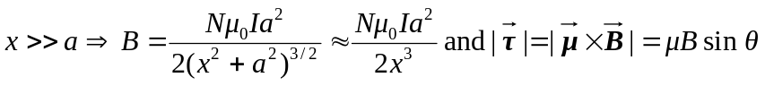
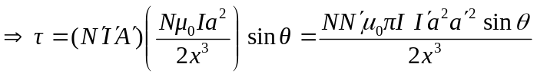
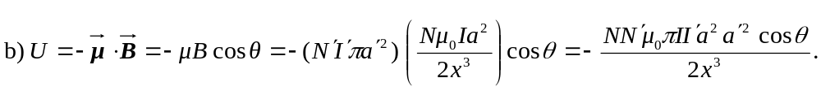
c) Having allows us to simplify the form of the magnetic field, whereas assuming 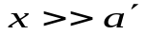means we can assume that the magnetic field from the first loop is constant over the second loop.

